[Week-05-02-Practice Session-Coding](http://www.rajalakshmicolleges.org/moodle/mod/quiz/view.php?id=123)

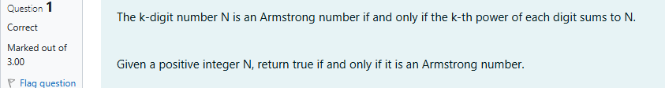

SOURCE CODE

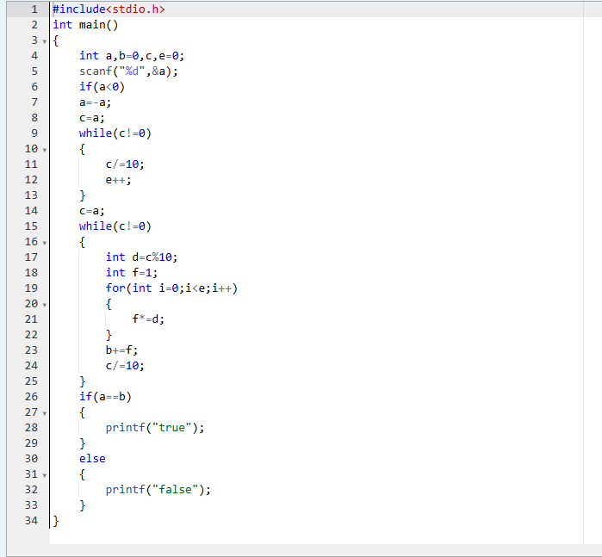

Output

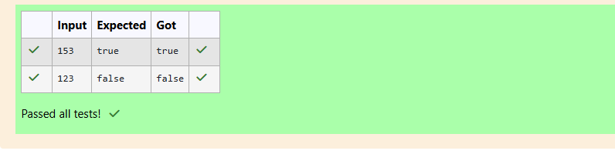



SOURCE CODE

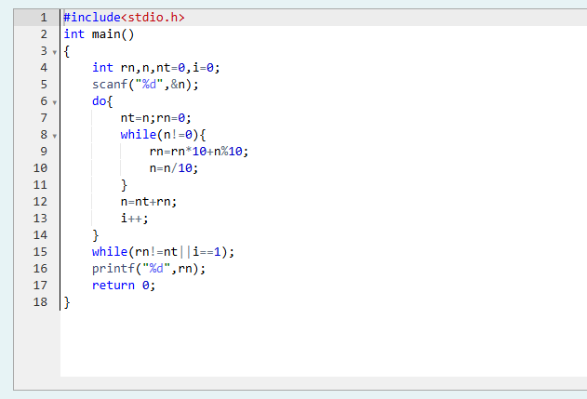

Result

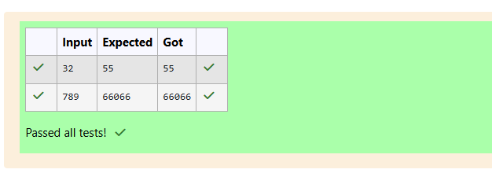

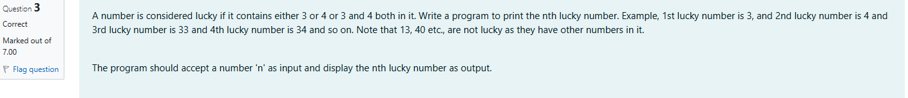

SOURCE CODE

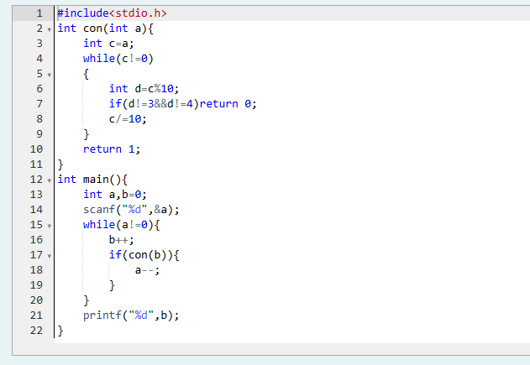

RESULT

